
Insurance: NYEIS Case Management
and Functionality
for Service Coordinators and Providers

A Statewide Training Sponsored by
New York State Department of Health
Bureau of Early Intervention

Presented by
Early Intervention Learning Network (EILN)
Just Kids Early Childhood Learning Center
(631) 924-2461
eilearningnetwork@gmail.com
www.eilearningnetwork.com

Trainer’s Guide

September, 2015
Revised December 2015

Insurance: NYEIS Case Management and Functionality
for Service Coordinators and Providers
September 2015

Guidance for the Trainer
The purpose of this training is to provide service coordinators, both initial and ongoing, with the knowledge and tools they need to perform to the best of their ability for every family they serve and to enhance/provide information on obtaining a family’s insurance information, which became their responsibility in 2013. This training is also available to municipal staff and providers although most of the responsibilities are those of service coordinators.

This training provides information in two formats; the first is a PowerPoint presentation and the second consists of live demonstrations in NYEIS. The trainer will demonstrate how to add and edit insurance data in NYEIS through live web-based presentations. Throughout the session the trainer will be switching between the PowerPoint presentation and live NYEIS demonstrations. [Note to Trainer and this is Optional: A recorded version of the live NYEIS demonstrations is available in the event the NYEIS Training Environment cannot be accessed.]
Each trainer will receive login credentials from the Bureau of Early Intervention to enable access to the NYEIS Training Environment to conduct the live demonstrations in NYEIS.
As participants arrive and during sign-in, trainers should get an idea of who their audience is. They should then tailor their presentation of the training (e.g., topics to spend a little more time on, specific questions to pose), to ensure that all materials are covered in such a way that participants leave with a good understanding of the course content. In addition, trainers should ask how many attendees have:
1. Access to NYEIS
2. Used NYEIS
3. Used NYEIS for one year (beginner level)
4. Used NYEIS for one to two years (intermediate level)
5. Used NYEIS for more than two years (proficient level)

The trainer should ensure that every participant signs in, whether they have registered in advance or are a “walk-in.”
Since there is a great deal of information to present, it is imperative to stay within the time frames set for each unit. It is also important to avoid diverting session time into discussions of specific problems and/or issues with the use of NYEIS. The trainer should refer participants to the NYEIS User Manual or the NYEIS Help Desk to obtain help with individual problems. Specific questions regarding billing/claiming and/or statewide early intervention policy, requirements, or interpretation of regulations should be referred by the trainer to DOH for clarification.

GROUP SIZE AND DISTRIBUTION
The training group size should ideally be no more than 40 participants.
To help participants identify their respective roles and get to know one another, participants can use name tags with information that includes their role in the EI system such as initial/ongoing service coordinators, EIO/Ds, and others. This is at the discretion of the trainer; use of name tags is not required.
MATERIALS and EQUIPMENT NEEDED
- Laptop and LCD Projector
- PowerPoint Slide Presentation
- Flip Chart Paper and Marking Pens (if trainer wishes to use)
- Index Cards
- Post-it Notes (optional)
- Name tags (optional)
- Participant Slide Packet
- Participant Training Packet (which includes handouts, resources and course evaluation)
- Insurance Tool Kit for Service Coordinators
- Trainer’s Guide
- CD/DVD with recorded version of the live NYEIS demonstrations (backup if trainer can’t access the NYEIS Training Environment)

PREPARATION OF MATERIALS
Each participant will receive three Training Packets:
- The first packet is the Participant Slide Packet, which contains the PowerPoint slides with room for taking notes.
- The second packet is the Participant Training Packet, which contains all of the training handouts, course evaluation, and helpful resources.
- The third packet is the Insurance Tool Kit for Service Coordinators.

The Trainer is provided with a copy of the training curriculum in PowerPoint format with trainer notes on each page. The trainer is also provided with a Training Manual that includes:

- Trainer’s Guide
- PowerPoint Curriculum in “Notes” format
- Participant Training Packet
- Insurance Toolkit
- Resource Section:
  - NYEIS User Manual
  - NYEIS Third Party Insurance Information Webinar PowerPoint (8/19/13)
- Copies of CEU Request Forms and Parent Stipend Forms

Insurance: NYEIS Case Management and Functionality
for Service Coordinators and Providers

Training Course Agenda
Total Training Time: 4 hours including 15 minute break

Time | Agenda Item
15 minutes | Welcome, Resources, Topics and Purpose  Slides 1 - 5
45 minutes | Unit 1—Accessing NYEIS  Slides 6 - 15  - NYEIS Demonstration 1: What Is the NYEIS Web-Based System?  - NYEIS Demonstration 2: How to Log Into NYEIS Through the Password Secure Health Commerce System Portal  - NYEIS Demonstration 3: How to Access Insurance Information in the Child’s NYEIS Integrated Case Home Page  - NYEIS Demonstration 4: How to Find and Navigate the Child’s Health Insurance Information in NYEIS  - NYEIS Demonstration 5: Important Information About Using Web-Based NYEIS
45 minutes | Unit 2—Obtaining/Collecting Insurance Information  Slides 16 - 33  - NYEIS Demonstration 6: Collection of Insurance Information Using Form A  - NYEIS Demonstration 7: How to Access Insurance Company Information; Verify Billing/Claiming Address; Enter Insurance Company/Policy Information  - NYEIS Demonstration 8: How to Document Parent Refusal to Provide Insurance Information
45 minutes | Unit 3—Verifying Insurance Information  Slides 34 - 55  - NYEIS Demonstration 9: Entering Information from Authorization to Release Health Information (Form C) and Request for Coverage Information (Form D) into NYEIS  - NYEIS Demonstration 10: Document Information from Form E, Written Referral from Primary Health Care Practitioner into NYEIS
15 minutes | BREAK
45 minutes | Unit 4 —Entering Insurance Information into NYEIS  Slides 58 - 74  - NYEIS Demonstration 11: How to document primary and secondary commercial insurance coverage  - NYEIS Demonstration 12: How to document: Services not Covered; Need for Prior Authorizations, PCP Referrals and Scripts; Receipt of Prior Authorizations and PCP Referrals  - NYEIS Demonstration 13: How to Document Child Health Plus Coverage in NYEIS  - NYEIS Demonstration 14: How to Document Medicaid Coverage from the Review of Child Identification Number Results Task; Document Medicaid Coverage Manually  - NYEIS Demonstration 15: How to Document Medicaid Managed Care Coverage
15 minutes | Unit 5: Editing insurance information in NYEIS  Slides 75 - 79  - NYEIS Demonstration 16: How to Edit (Third Party) Insurance Information; Edit Medicaid Child Identification Number Information
15 minutes | Debrief, Course Evaluation, Resources, Closing  Slides 80 - 85

Handout #1

Insurance: NYEIS Case Management and Functionality for Service Coordinators and Providers

Agenda

Welcome, Resources, Topics and Purpose

Unit 1– Accessing NYEIS
Unit 2 – Obtaining/Collecting Insurance Information
Unit 3 – Verifying Insurance Information

Break

Unit 4 – Entering Insurance Information into NYEIS
Unit 5 – Editing insurance information in NYEIS
Course Evaluation, Resources, Closing

Handout #2
Getting Started
Unit Overview

Getting Started reviews standard page anatomy, navigational buttons, links and
page layout of the New York Early Intervention System (NYEIS). Getting
Started is an Overview that provides the User with an understanding of how to
navigate through NYEIS.

NYEIS has a standard login and password process that determines a User's access
to information. Is it then determined, based on access rights, the type of
information displayed for viewing and editing for that User. For example, a
Provider would not be able to view the page that records a Child’s insurance
information and social security number. Also, based on User's role, a User may
only view certain pages and not be allowed to add, edit data or perform other
functions.

NYEIS Functional User roles/access rights will have their own names and may
not correspond to the job titles used by a Provider or Municipality which will vary
significantly.

Home Pages are a central location for detailed data and functions available for a
specific group or individual. For example, Home Pages exist for each Child, each
service Provider Agency and each User of the System. These pages allow easy
access for authorized Users to add, change and delete associated data elements.

Important Information
Pages in NYEIS are not automatically updated with data/information entered by
Users. Updated information or a page refresh occurs only when the page
displayed is submitted by clicking the Save or Next button on the current page.

SYSTEM REQUIREMENTS
The New York Early Intervention System (NYEIS) is built on the Curam
Software framework. Minimum requirements for running the application include:

Desktop Operating System: Windows XP or higher

Browser: Microsoft Internet Explorer (versions 7.0 and higher)

Microsoft Office: Microsoft Word 2003, 2007
Microsoft Excel 2003, 2007

Notes:
- Apple Mac OS is not supported.

- Microsoft Word is required for Communications Templates.  See Unit 4 – Case Management, Creating MS Word Communication for further information.

- Microsoft Excel is one of the Fiscal Payment file formats.  See Unit 8 – Provider Invoicing, Provider Electronic (837) Claiming and/or Unit 12– Municipal Financial, Sending Payment File to Municipal Financial for further information.

ACCESSING NYEIS
NYEIS is accessed through the Department of Health, Health Commerce System portal.
1. Open your Internet browser (Internet Explorer recommended) and enter
the following URL in the address bar:
https://commerce.health.state.ny.us

The New York State Department of Health, Health Commerce System login page displays.

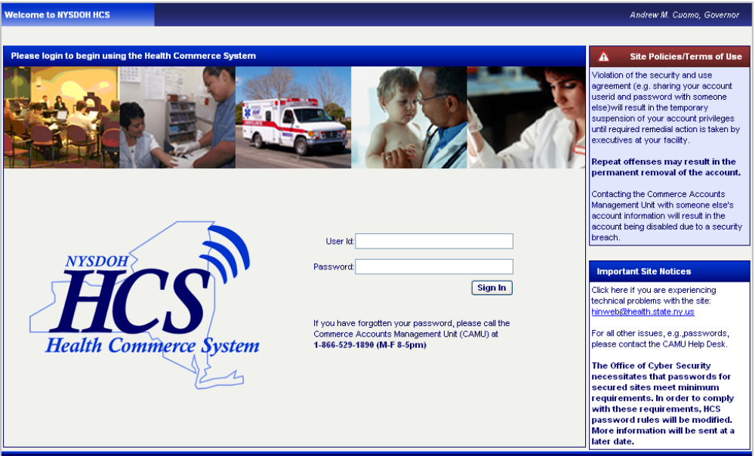
2. Enter in your Health Commerce System account username and password.
Click the Sign In button. The Health Commerce System Portal page displays.
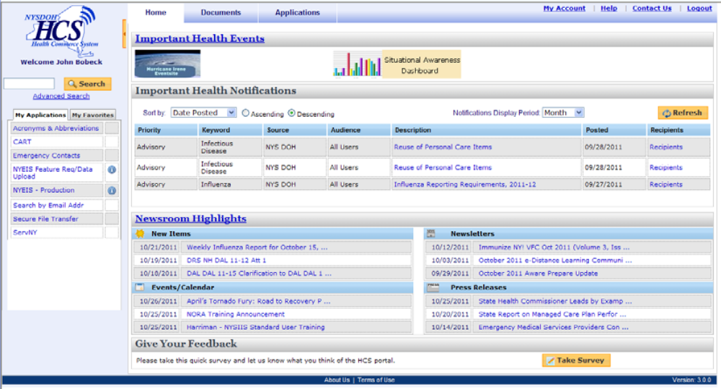

3. Click the NYEIS-Production link in the MY Applications section. The NYEIS Login page displays.

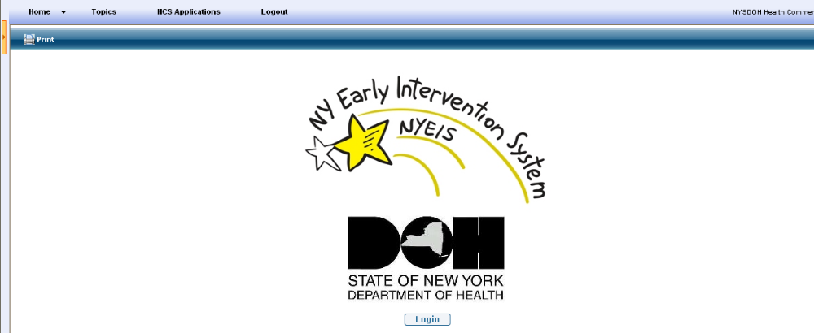

4. Click the Login button. Terms and Conditions page displays the first time that the User accesses NYEIS.
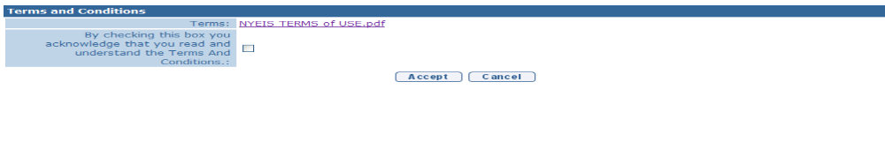

Click the Terms and Conditions.doc link to review the NYEIS Terms of Use/User Agreement. After reading, close the document to return to the application. Click the checkbox next to the By checking this box you acknowledge that you read and understand the Terms And Conditions.: field. Click the Accept button to indicate your acceptance of the terms of use.
User Home page displays.

Important Information
In order to access NYEIS a user is required to have 1) a Department of
Health, Health Commerce System user account, and 2) NYEIS User Account.
- Without the Health Commerce System account you cannot access the HCS Portal, which is the only “door” to NYEIS. Contact Commerce Accounts Management Unit (CAMU) at 866-529-1890 for assistance.
- Without a NYEIS User Account you will receive an error message when clicking the Login button referenced in step 4 above. Contact the NYEIS Help Desk at (518)783-9007 or NYEIS@cma.com for information about getting a NYEIS User Account.

Handout #3
NEW SERVICE COORDINATION RESPONSIBILITIES
OVERVIEW

Requirements in Public Health Law (PHL) and Insurance Law

- PHL 2544(2)(c): In consultation with the child’s evaluator, identifying whether a child is potentially eligible for programs and services under the Office for People with Developmental Disabilities (OPWDD) and, with parent consent, notifying the appropriate regional developmental disabilities services office of the potential eligibility of the child for such programs and services.

- PHL 2545(10): Implementing the IFSP, including:
  - Arranging for providers to deliver EIP services
  - Ensuring the timely delivery of services within 30 days

- PHL 2552 (1)
  - Reporting on the delivery of services to an eligible children in accordance with the child’s IFSP, in a manner and format determined by the municipality (guidance is not included in the tool kit, as this is a local responsibility).

- PHL 2548: All transition activities, including:
  - Facilitating the development of a transition plan
  - Providing written notification to the CPSE when a child is potentially eligible, if the parent does not object
  - Convening a transition conference with parental consent
  - Assisting the parent with timely referral to the CPSE
  - Obtaining parental consent and transferring evaluation, assessments, IFSPs, and other records to the CPSE and/or other programs

- PHL 2559(3)(a)(ii) Obtaining from the parent a written referral from a child’s primary health care provider as documentation of the medical necessity of early intervention services to facilitate claiming to private insurance.

- Insurance Law 3235-a(c) Providing information to the rendering provider assigned to provide services to the child regarding insurance benefits available to the child under his or her insurance policy.
Handout #4

NYEIS Third Party Insurance Targeted Resource

Collection and Viewing of Insurance Information

Question:
Who can add or edit a child’s insurance coverage in NYEIS?

Response:
Both the child’s Early Intervention Official/Designee (EIO/D) and service coordinator can manage a child’s insurance coverage in NYEIS.

Question:
Who is responsible for adding/editing the child’s insurance information into NYEIS?

Response:
It is the responsibility of the initial service coordinator to obtain and enter the child’s insurance information into NYEIS. In addition, initial service coordinators must discuss with the family the requirements in NYS Public Health Law and Insurance Law and inform parents of their rights, as well as the need to provide updated insurance information on an ongoing basis. Ongoing service coordinators are responsible to review and update the child’s insurance information as needed but no less than every 6 months with the review of the IFSP. In addition, ongoing services coordinators are also responsible for notifying providers of a change in the child’s insurance coverage.

Question:
Can a provider view a child’s insurance coverage in NYEIS?

Response:
Yes, provider users can view a child’s insurance coverage in NYEIS for children where the provider has an active service authorization (SA). Insurance information is located by accessing the child’s homepage and using the link for Insurance Coverage on the navigation bar. A provider no longer has access to a child’s insurance information when the service authorization closes. The child’s service coordinator and/or EIO/D can assist with providing insurance details to a provider after the SA closes.

Question:
How do I document a parent’s refusal to provide their insurance information in NYEIS?

Response:
In addition to the service coordinator documenting the parent's refusal in the child's record, on the child's homepage in NYEIS there is a cluster labeled Insurance Information and a place to indicate if the parent "declined to give insurance information". A parent may decline to provide insurance information without any impact on the delivery of EIP services

Documenting Medicaid Coverage

Question:
How is Medicaid coverage documented in NYEIS?

Response:
When an EIO/D is assigned, NYEIS automatically submits a request to NYS Office of Temporary and Disability Assistance (OTDA) to check if the child has or had Medicaid Coverage. For children identified as having Medicaid Coverage, a request is sent automatically every 6 months to OTDA to check if the child’s Client Identification Number (CIN) is still active in Medicaid. For children who have no Medicaid coverage, a CIN request is sent automatically every month. Users are informed of system-initiated CIN search results via a task that is created in the municipality Medicaid CIN work queue. The task displays the CIN search results from OTDA. Once the CIN results are reviewed and the appropriate CIN and coverage period are selected, NYEIS will automatically populate the selected Medicaid coverage on the child’s Insurance Coverage page.

Question:
Can a user initiate a manual check for a child’s Medicaid coverage information?

Response:
Yes, authorized municipal users and service coordinators have the ability to initiate a check for Medicaid coverage at any time by using the Check Medicaid Eligibility button. This generates an electronic request to the OTDA to check if the child has or had Medicaid Coverage. If the child has or had Medicaid, the user is informed via a task that is created to the user’s assigned tasks inbox. The task displays the CIN search results from OTDA. Once the CIN results are reviewed and the appropriate CIN and coverage period are selected, NYEIS will automatically populate the selected Medicaid coverage on the child’s Insurance Coverage page. If there was no Medicaid Coverage identified at OTDA, the task will be returned to the user’s assigned tasks inbox, but the task will be blank.

Question:
Can Medicaid coverage be manually entered into NYEIS?

Response:
Yes. It is possible that the Medicaid CIN Results task has not been completed and/or that the Medicaid eligibility check has not returned any results. If a child has Medicaid a user may manually enter the coverage information into NYEIS by clicking on the Insurance Coverage link in the navigation bar of the child’s homepage and selecting the New Medicaid Coverage button. The CIN number and effective date are required fields; all other information should be entered if known.

Question:
If a Medicaid CIN is incorrect, how can this number be corrected?

Response:
If the provider and municipality have determined that the CIN on the child’s Medicaid record in NYEIS is incorrect, this information must be corrected in order for claims to be appropriately processed to Medicaid. The incorrect CIN coverage period must be end dated with the same date as the start date. This effectively cancels the incorrect CIN. If a new CIN needs to be entered, the service coordinator and/or municipality can manually create the new CIN number and effective date. If the service coordinator/municipality is unable to add the new/correct CIN, the NYEIS Helpdesk must be contacted to have this number added.

Documenting Commercial Insurance Coverage

Question:
What information is required to be documented when recording a child’s commercial insurance coverage?

Response:
Once the Commercial Insurance Company is searched for and selected, additional information on the policy holder MUST be recorded in the Policy Holder Details Cluster. The Policy Number for Billing, Child ID Number, Effective Date, Policy Holder Relationship to Child, Policy Holder DOB, Gender and Address fields all must be recorded in order to save the commercial insurance coverage. Information in the Employer Details cluster is not required but should be entered if known.
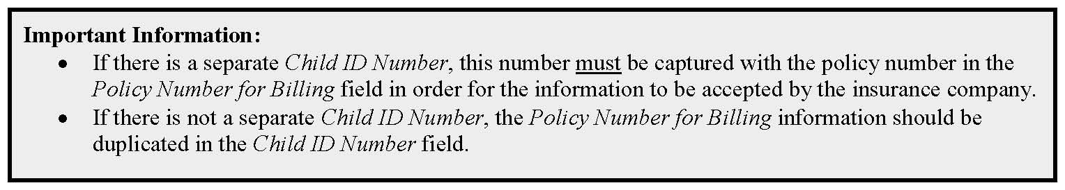

Question:
How can you find out if a child’s insurance plan is regulated by NYS?

Response:
You can search for insurance companies that are regulated by New York State at: http://www.dfs.ny.gov/insurance/tocol4.htm. By selecting the hyperlink for Insurance Company Search or typing the information into the search box on the upper right corner of the page, you should be able to find the insurance company by name and/or search through a listing of all insurance companies. In many cases, in order to accurately identify whether an insurance plan is regulated by New York State Insurance Law, service coordinators should contact the insurance company directly. The determination of whether it is regulated or not is made at the plan level (e.g., a single insurance company may have some plans that are regulated and others, such as self-funded plans, that are typically not regulated).

Question:
How do you document that a child’s insurance plan is not regulated by NYS in NYEIS?

Response:
If the insurance plan is not regulated by NYS insurance law, “no” should be indicated in the Plan Regulated by New York State field on the child’s insurance information page. If “no” is selected, claims will not be sent to the insurance company unless the Parent Consent to Bill field is “yes”. Parents must be advised by the service coordinator that payment for services could be applied towards annual and lifetime caps. If the parent has given consent to bill, they have been advised by the service coordinator that payment for services could be applied towards annual and lifetime caps, “yes” should be selected in the If not Regulated by NYS Law or Self/Funded, Does Parent Give Consent to Bill field. Claims will then be sent to the insurance company for reimbursement. Documentation of parental consent to bill is only required if the plan is not regulated by NYS.

Question:
What is the insurance sequence number?

Response:
The Insurance Sequence Number is captured in NYEIS to direct the order in which claiming is to occur. For example, if a Child has two Commercial Insurance policies, one policy must be claimed to as the primary (#1) before the other secondary (#2). Commercial Insurance must always be claimed first, prior to Medicaid. When editing Commercial Insurance Coverage, it is important to remember to change the sequence number as needed to ensure appropriate claiming.

Question:
If the child has Child Health Plus must this be documented in NYEIS?

Response:
Yes. If the child has Child Health Plus, this must be documented in NYEIS.

Question:
If a child has Child Health Plus, how is this documented in NYEIS?

Response:
The Child Health Plus coverage information must be entered as Commercial Insurance coverage information into NYEIS. “Yes” must be selected in the Is Plan Child Health Plus? field and in the Policy Holder Details cluster, the Policy Holder Relationship to Child field must be completed with “self”, which will then require that the Policy Number for Billing and Effective Date fields be completed. If there is not a separate Child ID Number, the Policy Number for Billing Information should be duplicated in the Child ID Number field. Once saved, all other fields will be prepopulated with information on the child that is already available in NYEIS (name, address, etc.). No additional information will be required in order to save the Child Health Plus coverage.

Question:
If the child has Medicaid Managed Care must this be documented in NYEIS?

Response:
Yes. When documenting the Commercial Insurance Coverage the Is Plan Medicaid Managed Care? field is a required filed in NYEIS. This field is defaulted to “No”. If the child is enrolled in Medicaid Managed Care, “Yes” must be selected in this field.

Question:
If a child has Medicaid managed care how should this documented in NYEIS?

Response:
If a child’s plan is Medicaid Managed Care, both the Medicaid CIN information and the Medicaid Managed Care insurance company information must be documented in NYEIS. The CIN must be recorded prior to entering the child’s managed care information as commercial insurance coverage. The child’s Medicaid managed care information must still be entered as commercial insurance coverage after recording the child’s CIN (see Documenting Medicaid Coverage questions above).

Once the child’s Medicaid coverage has been entered, the Medicaid Managed Care coverage information must be entered as Commercial Insurance coverage information into NYEIS. “Yes” should be selected in the Is Plan Medicaid Managed Care? field and in the Policy Holder Details cluster, the Policy Holder Relationship to Child field must be completed with “self”. When “self” is selected, only the Policy Number for Billing and Effective Date fields must be completed. Once saved, all other fields will be prepopulated with information on the child already available in NYEIS (name, address, etc.). No additional information will be required in order to save the Medicaid Managed Care coverage.

Question:
Is there an alert in NYEIS when Insurance Coverage information for a child has changed?

Response:
Currently, there is no alert in NYEIS when insurance coverage for a child had changed. Service coordinators are responsible for collecting, and documenting insurance information in NYEIS, and providing updated information to providers.

Subrogation
Question:
How can I generate the Required Notice of Subrogation template in NYEIS?

Response:
Providers may generate the required notice of subrogation template in NYEIS by clicking the Communications link off of the child's Integrated Case Homepage. The user can then click the Create MS Word button and create the communication. The template can be accessed by clicking on the search icon next to the Template Name field at the bottom of the page. Users can also download the Required Notice of Subrogation template to their desktop and fill in the data manually. Providers should maintain documentation of the subrogation notification in the child’s record. Completed copies can also be scanned and attached into NYEIS.

Question:
Does the Required Notice of Subrogation need to be sent to the insurance company if the plan is not regulated by NYS and the parent has not consented to bill their non-regulated insurance company?

Response:
If the plan is not regulated by New York State and the parent has not consented to bill their non-regulated insurance, the Required Notice of Subrogation does not need to be sent.

Question:
Is there any time that the Required Notice of Subrogation does not need to be sent?

Response:
The Required Notice of Subrogation does not need to be sent to Medicaid, Medicaid Managed Care or Child Health Plus. It also does not need to be sent for service coordination or special instruction services.

Question:
Is there a mechanism in NYEIS to send the Required Notice of Subrogation directly to the insurance company, or is it strictly by fax or mail?

Response:
The Required Notice of Subrogation in NYEIS currently does not pre-populate with information stored in NYEIS. Providers must download the template to their computer's desktop and fill it in manually, save, and print. They can then mail or fax the completed form to the insurance company. They can also attach completed forms back into NYEIS but a hard copy must be saved in the child's record.

Request for Coverage Information

Question:
How can I generate the Request for Coverage Information template in NYEIS?

Response:
Service coordinators may generate the Request for Coverage Information template in NYEIS by clicking the Communications link off of the child's Integrated Case Homepage. The user can then click the Create MS Word button and create the communication. The template can be accessed by clicking on the search icon next to the Template Name field at the bottom of the page. Users can also download the template to their desktop and fill in the data manually. Users may also use the Request for Coverage Information template provided by the Department in the Insurance Tool Kit and scan and attach it into NYEIS. Service coordinators should maintain documentation of the Request for Coverage Information in the child’s record.

Written Referral From Primary Care Practitioner Documentation of Medical Necessity for Third Party Claiming

Question:
What is the “Written Referral from Primary Care Practitioner Documentation of Medical Necessity for Third Party Claiming”?

Response:
Pursuant to New York State Public Health Law Section 2559(3)(a)(ii), parents are required to provide the Early Intervention Program with a written referral from a primary health care practitioner. This referral serves as documentation of the medical necessity of early intervention services for their children who have been found eligible through a multidisciplinary evaluation for the Early Intervention Program. The “Written Referral from Primary Care Practitioner Documentation of Medical Necessity for Third Party Claiming” captures this referral.

Question:
Where can I document in NYEIS that a “Written Referral from Primary Care Practitioner Documentation of Medical Necessity for Third Party Claiming” was obtained?

Response:
The service coordinator can document that a “Written Referral from Primary Care Practitioner Documentation of Medical Necessity for Third Party Claiming” was obtained in the comment section on the child’s commercial insurance coverage page in NYEIS.

Question:
Where can I attach a copy of the “Written Referral from Primary Care Practitioner Documentation of Medical Necessity for Third Party Claiming” in NYEIS?

Response:
The “Written Referral from Primary Care Practitioner Documentation of Medical Necessity for Third Party Claiming” should be attached using the Attachments link on the child’s Integrated Case Homepage in NYEIS.

Creating Services Not Covered in NYEIS

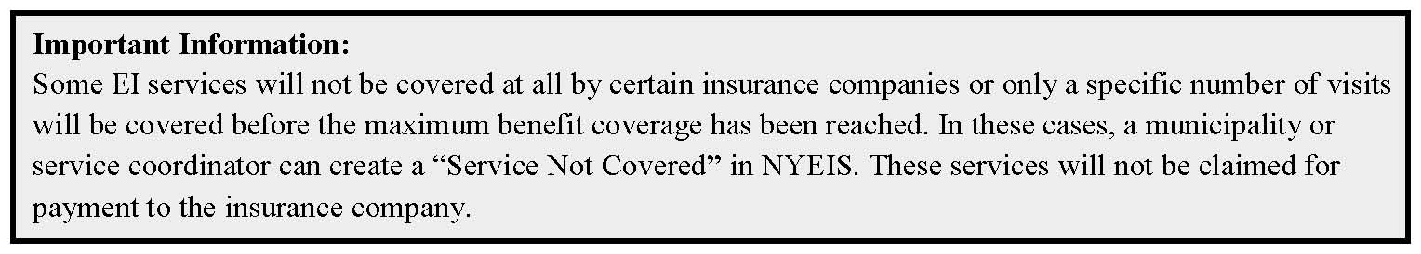

Question:
Where can I find information on services that are not covered by commercial insurance companies?

Response:
Insurance companies must return the “Request for Coverage Information” form to the municipality within 15 days of their receipt of the form. This form includes information on the number of annual covered visits for services as well as service that are not covered at all.

Question:
If services are not covered under a child’s commercial insurance plan, must these services be entered as Services Not Covered in NYEIS?

Response:
Yes, this information must be entered on the child’s Commercial Insurance coverage pages in NYEIS. When viewing the child’s commercial insurance page, from the navigation bar click on the Service Not Covered link and click on the New button to record the details about the service, qualified personnel, method, reason, and effective dates for the service not covered.

Question:
Do I need to enter Service Coordination, Special Instruction, Respite and Transportation as services not covered in NYEIS?

Response:
No. Service Coordination, Special Instruction, Respite and Transportation services do not need to be entered into NYEIS as services not covered. These service types are already excluded from commercial insurance claiming.

Question:
If an end date for the service not covered is entered, will the services be billed to commercial insurance immediately subsequent to the end date entered?

Response:
Yes. If an end date for the service not covered is entered, billing to commercial insurance will occur immediately subsequent to the end date entered.

Creating Prior Authorizations

Question:
What is a Prior Authorization?

Response:
Commercial insurance often require documentation of medical necessity or other child record information before covering certain services. Commercial insurance will provide a prior authorization number as well as the amount of visits that are authorized before an additional prior authorization must be obtained.

Question:
Where can I find information on if insurance companies require prior authorizations?

Response:
Insurance companies must return the “Request for Coverage Information” form to the municipality within 15 days of their receipt of the form. The form includes information on prior authorizations required in order to ensure coverage.

Question:
If prior authorization is required by the child’s commercial insurance company in order to provide coverage for a service, must this information be documented in NYEIS?

Response:
Yes, this coverage information must be entered on the child’s commercial insurance coverage page in NYEIS. When viewing the child’s commercial insurance coverage page, from the navigation bar, click on the Prior Authorizations/Referral link and click on the New button. A prior authorization may be needed for a specific Service, Qualified Personnel and/or Method. Once the details of the prior authorization are recorded, ensure that the Prior Authorization checkbox is checked. When a service authorization is created that requires a request for a prior authorization, the child’s EIO/D receives notification through a task to request the prior authorization. The EIO/D may forward this task to the child’s service coordinator to complete.

Question:
Once a prior authorization is received from the insurance company, must it be documented in NYEIS?

Response:
Yes, this information must be entered on the child’s commercial insurance coverage page in NYEIS. When viewing the child’s commercial insurance coverage page, from the navigation bar, click on the Prior Authorizations/Referral link and click on the New Prior Authorization button to search for the Service Authorization associated with the respective service for which the prior authorization was required and document the prior authorization details.

Question:
Can “The Written Referral from Primary Care Practitioner Documentation of Medical Necessity for Third Party Claiming” which is obtained by the service coordinator to document medical necessity, be used to request and to meet the insurance company requirement for prior authorizations?

Response:
Yes, the “Written Referral from Primary Care Practitioner Documentation of Medical Necessity for Third Party Claiming” which is obtained by the service coordinator to document medical necessity provides a column for prior authorization numbers to be entered by the insurer. Once the form is returned from the physician, the service coordinator may send the form to the insurance company to request needed prior authorizations. If these prior authorization numbers are entered by the insurer, then the form may be used to meet the insurance company requirement for prior authorizations. This information must be documented in NYEIS as indicated above.

Primary Care Physician Referrals

Question:
What is a Primary Care Physician Referral?

Response:
Commercial insurance often requires that a Primary Care Physician (PCP) document medical necessity before covering certain services by providing a written referral for the specific service to be provided.

Question:
Where can I find information on if a PCP referral is required by an insurance company?

Response:
Insurance Companies must return the “Request for Coverage Information” form to the municipality within 15 days of their receipt of the form. The form includes information on specific referral procedures that must be followed in order to ensure coverage.

Question:
If a PCP referral is required by the child’s commercial insurance company in order to document medical necessity and provide coverage for a service, must this information be documented in NYEIS?

Response:
Yes, this coverage information must be entered on the child’s commercial insurance coverage page in NYEIS. When viewing the child’s commercial insurance page, from the navigation bar, click on the Prior Authorizations/Referral link and click on the New button. A PCP referral may be needed for a specific service, qualified personnel and/or method. Once the details of the PCP referral needed are recorded, ensure that the Primary Care Physician Referral Required checkbox is checked. When a service authorization is created that requires a request for a Primary Care Physician Referral, the child’s EIO/D receives notification through a Task to request the PCP Referral. The EIO/D may forward this task to the child’s service coordinator to complete.

Question:
Once a Primary Care Physician Referral is received from the PCP, must it be documented in NYEIS?

Response:
Yes, this information must be entered on the child’s Commercial Insurance Coverage page in NYEIS. To document that a PCP referral was received, the user must view the child’s commercial insurance page. From the navigation bar, the user must then click on the Prior Authorizations/Referral link and then click on the New Primary Care Physician Referral button. This will allow the user to search for the service authorization associated with the service for which the PCP Referral was required. The PCP referral details must then be documented.

Question:
Can “The Written Referral from Primary Care Practitioner Documentation of Medical Necessity for Third Party Claiming” which is obtained by the service coordinator to document medical necessity be used to meet the insurance company requirement for a PCP referral?

Response:
Yes, if the “Written Referral from Primary Care Practitioner Documentation of Medical Necessity for Third Party Claiming” which is obtained by the service coordinator to document medical necessity contains a PCP referral number, then it may be used to meet the insurance company requirement for a PCP referral. The PCP referral number is the referring physicians NPI #. This information must be documented in NYEIS as indicated above.

Scripts

Question:
Is the script on the child’s Commercial Insurance Coverage page in NYEIS the same script that is required for the delivery of some EI services (OT, PT etc.)?

Response:
The script referred to on the child’s Commercial Insurance coverage page in NYEIS is a script from a primary care physician that may be required by the insurance company in order to document medical necessity and provide coverage for a service. This script required by the insurance company, may be used to meet the need for the order required in EIP regulation 69-4.11 (a)(10)(ii) if this script contains all the required elements for an order under this section.

Question:
If a script is required by the child’s commercial insurance company in order to document medical necessity and provide coverage for a service, must this information be documented in NYEIS?

Response:
Yes, this coverage information must be entered on the child’s commercial insurance coverage page in NYEIS. When viewing the child’s commercial insurance page, from the navigation bar, click on the Prior Authorizations/Referral link and click on the New button. A script may be needed for a specific service, qualified personnel and/or method. Once the details of the script needed are recorded, ensure that the Script checkbox is checked to document that a script is required. Information on scripts should be provided from the insurance company as a result of the “Request for Coverage Information” form.

For questions on this document, please contact BEI at (518)473-7016, or at bei@health.state.ny.us
Handout #5
Helpful Resources
NYEIS and BEI Electronic Mailing List Subscription
- NYEIS Mailing List: When you subscribe, you will receive the latest information available regarding NYEIS. Send an e-mail to nyeislist@health.state.ny.us with "Subscribe" in the subject line and include your first and last name in the body of the e-mail. Please do not send more than one request to subscribe.
To unsubscribe, send an e-mail to nyeislist@health.state.ny.us with "Unsubscribe" in the subject line and be sure to include your name in the body of the e-mail.

- BEI Mailing List: When you subscribe, you will receive an email notification each time a new item is posted to the Bureau of Early Intervention’s web page, and notifications about other important information. Send an e-mail to eiplist@health.state.ny.us with "Subscribe" in the subject line and include your first and last name in the body of the e-mail. Please do not send more than one request to subscribe.
To unsubscribe, send an e-mail to eiplist@health.state.ny.us with "Unsubscribe" in the subject line and be sure to include your name in the body of the e-mail.

Websites
- New York State Department of Health (DOH): https://www.health.ny.gov/
- Bureau of Early Intervention: http://www.health.ny.gov/community/infants_children/early_intervention/
- Early Intervention Learning Network (EILN): www.eilearningnetwork.com
- EI Billing: www.EIBilling.com
- NYEIS: Go to Targeted Resource Link for information on Insurance http://cma.com/client-portals/new-york-early-intervention-system-nyeis/nyeis-guide/nyeis-targeted-resources/
  - NYEIS User Manual: http://cma.com/client-portals/new-york-early-intervention-system-nyeis/nyeis-guide/

Recommended Related Trainings
- Visit the EILN website for information about the following recommended statewide trainings:
  - Advanced Service Coordination: Working with Families Training
https://www.eilearningnetwork.com/index.php/course-descriptions#ASC-1
- NYS DOH NYEIS Third Party Insurance Information Webinar: Click the Recorded Sessions link on the left sidebar, scroll to the NYEIS Third Party Insurance Information Webinar link
  - https://nysdoh.webex.com/
- PCG Training 103, Part 1: Accurate Insurance Information Collection, and Training 103, Part 2: Insurance Data Entry for Claiming
  - https://www.eibilling.com/Public/TrainingVideos/PCGTraining.aspx

Recommended Reading
- Insurance Tool Kit for Service Coordinators:
  - http://www.health.ny.gov/community/infants_children/early_intervention/memoranda.htm and/or can be accessed from:
  - https://support.eibilling.com/KB/c13/service-coordination-tool-kit.aspx
- NYEIS User Manual, Unit 1: Getting Started, Accessing NYEIS Pages 8-11: http://cma.com/client-portals/new-york-early-intervention-system-nyeis/nyeis-guide/
- NYEIS Third Party Insurance Targeted Resource Q & A: http://cma.com/wp-content/uploads/2014/08/NYEISThirdPartyInsuranceTargetedResourceAug2013.pdf
- NYEIS Third Party Insurance Information Webinar PPT 8/19/13: https://nysdoh.webex.com/
- New Service Coordinator Responsibility Overview Requirements in Public Health Law and Insurance Law: https://support.eibilling.com/KB/a48/new-service-coordination-responsibilities.aspx

Important Contact Information
- Bureau of Early Intervention
- Phone: 518-473-7016
- Email: bei@health.ny.gov

- Public Consulting Group (PCG):
- Customer Service Center: 1-866-315-3747, open 7:00 am to 7:00 pm EST

- NYEIS Help Desk:
- Phone: 518-640-8390
- Email: NYEIS@cma.com

EI Insurance Flow
Does the child have health insurance at
time of referral to EIP?
(If unable to obtain at referral, SC to follow-up with family when scheduling initial contact. At the time of referral, insurance information can only be transmitted to the municipality with parental consent.)

YES, What type of Insurance? (complete Collection of Insurance Information form)
NO
Medicaid Only
Medicaid Managed Care, Or Child Health Plus
Other
The SC is responsible for assisting parent in identifying and applying for benefit programs in which the family maybe eligible.
Call the insurance company to determine if the Insurance is regulated or not regulated

NO
YES
Give family “Parent Letter Regarding Regulated Insurance”
Give family “Parent Letter Regarding Non-Regulated Insurance”

Ensure family understands letter. Review and Fill Out : Consent to Bill Non-Regulated Insurance Form
Obtain Parental consent on the Authorization to Release Health Insurance Information
Complete Request for Coverage Information (Commercial Insurance Only. Not needed for Medicaid)
Did the family consent to bill the non-regulated insurance?
Send Authorization and Request for Coverage Information to the child’s insurance company, use correspondence address.
YES
NO
Is the child eligible for EIP?

Consent MUST be updated at every IFSP Meeting
YES

NO
Complete PCP Referral for children with Third Party Insurance coverage (not Medicaid) for all IFSP Services.

Send completed PCP referral to provider
YES
Provider to complete and send subrogation notice to Third Party Insurance company only (not Medicaid or Managed Care).

ISC/OSC Insurance Responsibilities
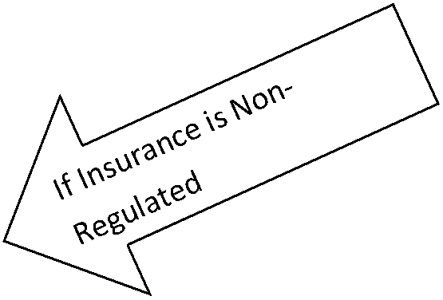
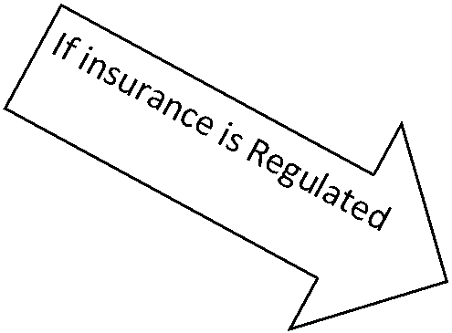
Initial Service Coordinator
Ongoing Service
Coordinator
New Referral
Obtain Insurance/benefit information from families
Fill out Collection of
Insurance Form

Provide Families letter regarding Non-Regulated Insurance
Verify Coverage
information and determine if plan is regulated or non-regulated.
Call the insurance company

Check websites for
eligibility information

www.wnyhealthenet.org
www.epaces.org
Review and have
families, if willing, sign Consent to Bill Non-Regulated Insurance

Enter Insurance/Benefit information in NYEIS.

Include in comments section insurance
company correspondence address (if different from billing/claiming address)
Send Authorization to
Release Insurance and
Request for coverage
information to the
insurance company
Notify Providers of changes to a child’s insurance
Obtain Written
Referral on behalf of the family to cover all
initial IFSP services
Verify Insurance coverage with families/insurance company monthly.

If there is a new insurance/benefit fill out Collection of Insurance Form
Review and have families sign Authorization to
Release
Insurance Information Form

Update Referral as a NEW service is added to the IFSP
Provide Families letter regarding Regulated Insurance
Course Evaluation
DATE: LOCATION: _______ INSTRUCTOR(S): ____ _
TITLE OF TRAINING: Insurance: NYEIS Case Management and Functionality for Service Coordinators and Providers

EVALUATION FORM: Please circle the number you believe best represents your evaluation of the trainer(s) and the content.
- How would you rate the trainer(s) in terms
of knowledge? 5 4 3 2 1
Excellent Needs Improvement
- How would you rate the trainer(s)
in terms of presentation and style? 5 4 3 2 1
Excellent Needs Improvement
- How would you rate the trainer(s)
in terms of encouraging discussion
and answering questions? 5 4 3 2 1
Excellent Needs Improvement
- In general, how would you rate this
workshop? 5 4 3 2 1
Excellent Poor
- How helpful were the training materials
used during the training? 5 4 3 2 1
Very Helpful Not Helpful
- To what extent do you think the training
materials and handouts will be useful to you? 5 4 3 2 1
Very Useful Not Useful
- Did the content of the workshop
give you a better understanding of your role
in the Early Intervention system? 5 4 3 2 1
Yes, Very Much No, Not At All
- The portion of the workshop I found most valuable was:

- The portion of the workshop I found least valuable was:

- Please indicate which issue or topic discussed at this training you would like to see addressed in more detail at follow up training or would like more information about:

- How did you learn about this workshop?

- Are you a: Parent or EI Professional (circle one)

__ __ ____
Name (Optional if not requesting CEUs) Affiliation
Please provide additional comments on the reverse side

