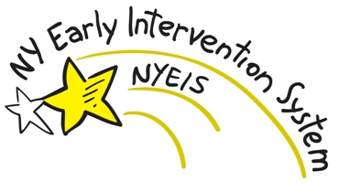

**2**

**Provider authorized**

**service delivered**

**1**

**EI Provider Service Authorization**

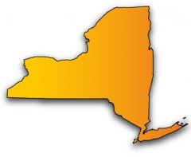

**Provider Claims**

**Muni share**

**Bi-Weekly report on payment owed for non-covered services**

**Escrow Account**

Provider Payments not covered by Third Party Payout

**Payments for partial**

**non-covered services**

**State Fiscal Agent**

**3**

**Submit Claims**

***Online or via 837 File Submission (NYEIS)***

***(NYEIS)***



**Business Rules**

**&**

**Edit Checks**

**$ Payment**

**4**

**7**

**$ Payment**

**Initial Provider Claims from NYEIS to SFA**

**Municipality**

**State share – 49% back to municipality**

**$ Payment**

**5**

**Remittance**

**Muni deposit to cover 100% owed to providers**

**Commercial Insurance**

**Claim**

**8**

**$ Payment**

**6**

**Medicaid**

**(3) Report to DOH**

***100% County funds in first instance***

**Remittance**

**State contributes state share (lag remains in effect)**

**Claim**